

**FUN ZONE WEBSITE**

**DOCUMENTATION**

|  |  |
| --- | --- |
| **Authors**: | Duong Pham Huu |
| Viet Nguyen Ngoc |
| Thuy Nguyen Trinh Thanh |
| **Batch**: | C1908G |
| **Group**: | 1 |
| **Instructor**: | Bach Le Viet |

Ha Noi, July 2020

**TABLE OF CONTENTS**

1. Problem Definition 3

1.1. Problem Abstraction 3

1.2. The current System 3

1.3. The Proposed System 4

1.3.1. Boundaries of the System 5

1.3.2. Hardware and Software Requirements 5

2. Customer Requirements Specification 5

2.1. Users of System 5

2.2. System Functions. 6

3. System Designs 9

3.1. Use case diagram 9

3.2. Entity relationship diagram 10

3.3. Database Design 11

3.4. Sitemap 12

4. Website Display 13

4.1. User Interface 13

4.2 Admin Interface 17

5. Algorithm 20

6. Conclude and Oriented development 21

6.1 Conclude 21

6.2 Oriented development 22

# 1. Problem Definition

## 1.1. Problem Abstraction

When human demand is increasing, they have more and more creative ideas to meet their own needs. That is the reason why Information Technology was born and developed at such as high level. We cannot deny the enormous benefits that Information Technology has brought for our life. IT is a modern invention that reaches the top of the human world and it becomes an indispensable friend in each of us. Today, the website not only have a important role in the field of entertainment, economy, politics but also deeply affects the spiritual life of every person. With the development of technology, the Website will gradually serve and replace old business methods such as advertising on television or leaflets. To sum up, I believe that Modern Information Technology has helped enterprises to promote superiority to bring competitive advantage, be more efficient and not limited in space and time.

Due to these practical needs, we decided to create ideas and implement a website to bring all the most interesting things of FUN ZONE to customers not only in our country but also around the world.

## 1.2. The current System

At present, FUN ZONE and general entertainment areas similar to FUN ZONE mainly advertise in the traditional way (leaflets, banners, billboards, newspapers, media, ...). These methods require a lot of time, money, and effort but the effect is not high. In the age of Internet development, people have access to information on the Internet faster and more quickly, paper newspapers are gradually replaced by online newspapers, which show that traditional marketing methods gradually become less effective. Combining that traditional method with brand development, promote the image, and product marketing on the Website is a quite potential and very feasible method.

## 1.3. The Proposed System

-          System name: FUN ZONE Website

-          Website function:

•        Provide information about the FUN ZONE: tourist attractions, entertainment centers, restaurants, hotels, home Stay to kiosks selling fast food, drinks, ...

•        Provides selection, reservation, and online payment services (tickets, restaurants, hotels, homestay, ...).

-          System function:

•        Client:

1)    Provide general information about FUN ZONE including General introduction, areas, diagrams, location, address, contact information, social media address.

2)    Providing tourism and resort services, including details of entertainment services, system of restaurants, hotels, homestay, ...

3)    Provide current status of services, time, prices as well as forms of payment.

•        Admin:

1)    Manage items, details, current status of regions, and services.

2)    Manage prices of services, fares, and offers from month to month.

3)    Manage events that have been, are happening and about to happen.

4)    Customer information management and security.

### 1.3.1. Boundaries of the System

FUN ZONE is aimed at all types of customers:

-         Customers who have demand for entertainment.

-         People who want to find information about travel, and entertainment.

-         Domestic and foreign customers.

          We have separated areas suitable for different audiences and specific ages, to ensure the experience and safety for all customers who come to the FUN ZONE.

### 1.3.2. Hardware and Software Requirements

-         Hardware: Personal laptop

-         Software: PHP, My SQL, HTML, JavaScript, CSS…

# 2. Customer Requirements Specification

## 2.1. Users of System

-         Client:

•        Visitors to the website are allowed to view the FUN ZONE's information, description, location, and contact information.

•        Customers can view the content to know more details about each item.

•        Customers can easily locate the location through the specified address. Customers have the right to feedback and review the places they have visited, assessing the quality of each object.

•        Customers can use the form of reservation services, requiring customers to fill in the information required by the FUN ZONE to ensure the rights and benefits of reservation.

-         Admin: is a person with rights to manage the whole system:

•        Retrieving database

•        Insert, edit, update the content of all categories, events.

•        Update current status information of all services.

•        Insert, edit, delete the admin account.

•        Management and protection of customer information.

•        Update fares from time to time, incentives for customers.

•        …

## 2.2. System Functions.

-         Client:

•        Information display function:

▪  Description: For all customers accessing the website, they can view general information, detailed descriptions of all services and facilities of FUN ZONE.

▪  Input: It does not require customers to provide personal information. Customers only need to visit the links to view the information they want to see.

▪  Mechanism of action: Retrieve DB (Database).

▪  Output: Display specific details about the object that customers want to see on the UI. This information is retrieved from the database.

•        Information search function:

▪  Description: Customers can search for the information they want through text.

▪  Input: Ask customers to enter a text containing no information related to the object to be searched.

▪  Mechanism of action: Retrieve DB, filter out objects(*) with information, the description related, or contain text that customers enter.

▪  Output: Displays a list of objects(*) that are relevant to what the customer is searching for. Customers can access the link to view specific information and description. This information is retrieved from the database.

***\*Objects*** *include: FUN ZONE overview, entertainment areas, restaurants, hotels, homestays, tickets, events that have been and going on.*

-         Admin:

•        Admin right:

▪  Input: Admin must enter the correct account and password.

▪  Mechanism of action: Access the Database and compare books with the account and password entered.

▪  Output: If correct the user will have admin access. If it is wrong, the login session fails, reports an error, and returns to the login screen.

•        Function to insert and edit objects(*):

▪  Input: Admin enters much information, description, images, ... of the item to be inserted.

▪  Mechanism of action: The input information will be saved to the Database.

▪  Output:

o   Notification of session results.

o   Processing, displaying newly inserted items on the UI.

•        Function to delete objects(*):

▪  Input: Admin presses the Delete button →  OK to delete the item to remove the selected objects(*)…

▪  Mechanism of action: After it is successfully deleted, the item will be deleted from the database.

▪  Output:

o   Notification of session results.

o Remove them on the UI.

***\*Objects*** *include: FUN ZONE overview, entertainment areas, restaurants, hotels, homestays, tickets, events that have been and going on.*

•        Function to insert, edit, delete admin accounts.

•        Customer's ability to view, modify, or delete a customer order form if required by the customer.

# 3. System Designs

## 3.1. Use case diagram

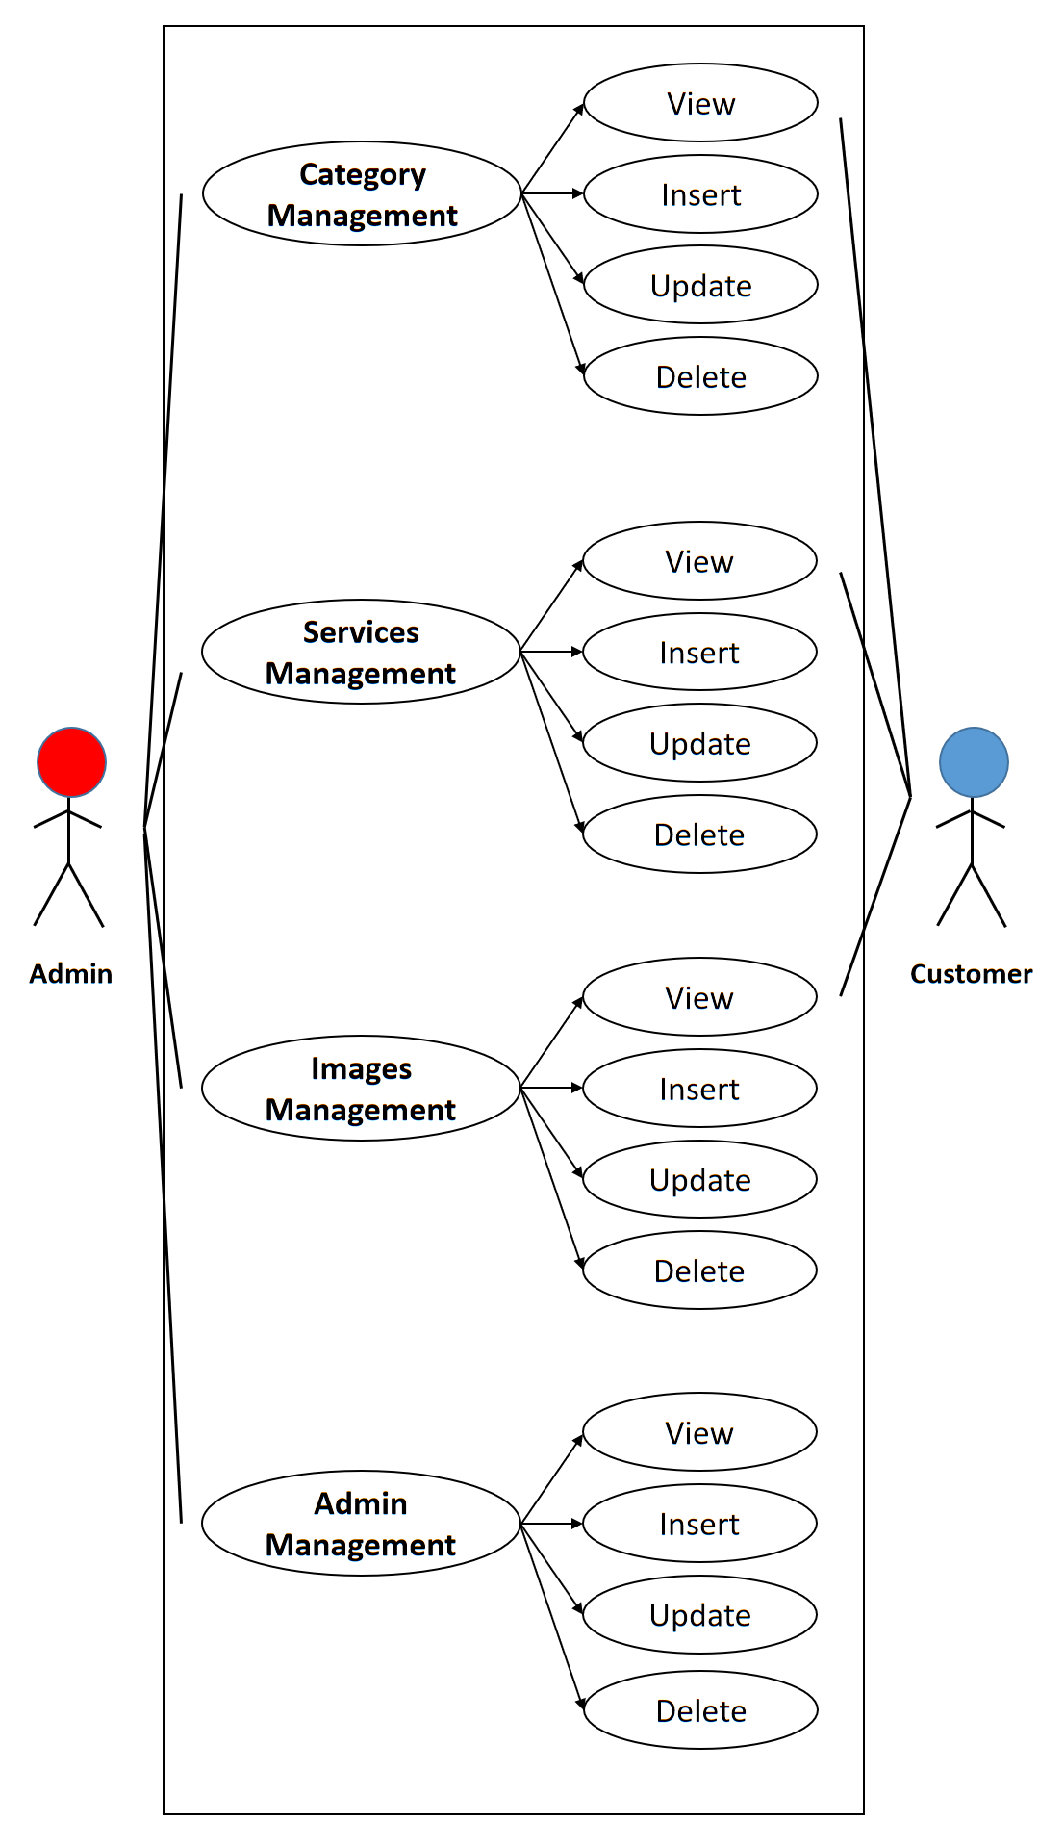

*Use case diagram*

## 3.2. Entity relationship diagram

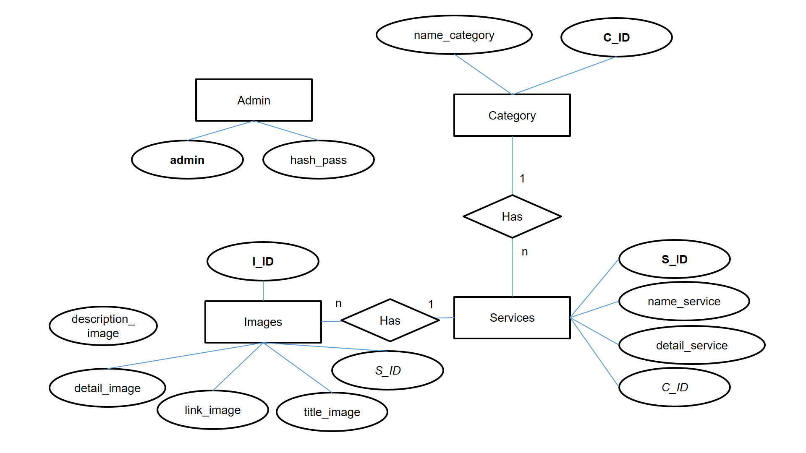

*ER Diagram*

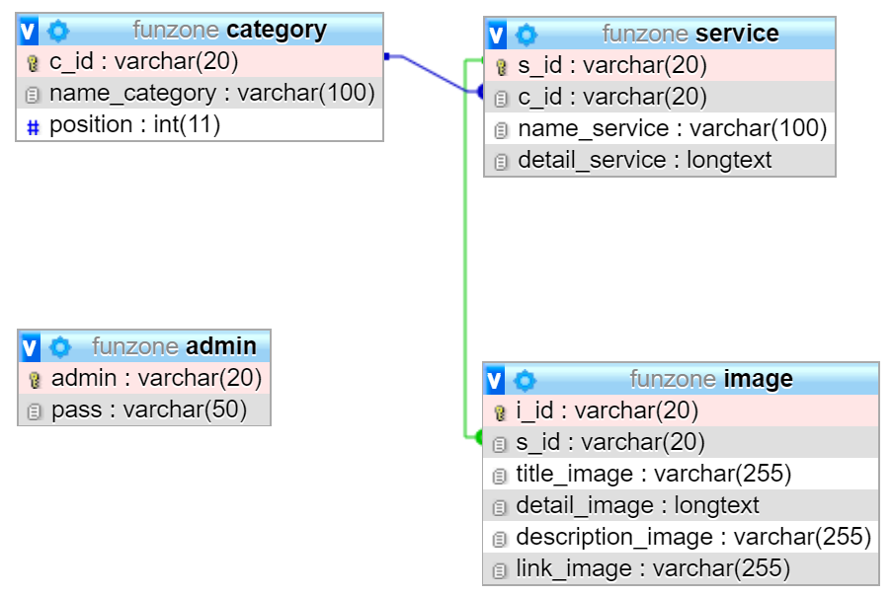

## 3.3. Database Design

ADMIN

|  |  |  |  |
| --- | --- | --- | --- |
| **Properties** | **Datatypes** | **Size** | **Key** |
| admin | VARCHAR | 20 | Primary |
| pass | VARCHAR | 50 |  |

CATEGORY

|  |  |  |  |
| --- | --- | --- | --- |
| **Properties** | **Datatypes** | **Size** | **Key** |
| c_id | VARCHAR | 20 | Primary |
| name_category | VARCHAR | 100 |  |
| position | INT | 11 |  |

SERVICE

|  |  |  |  |
| --- | --- | --- | --- |
| **Properties** | **Datatypes** | **Size** | **Key** |
| s_id | VARCHAR | 20 | Primary key |
| c_id | VARCHAR | 20 | Foreign key |
| name_service | VARCHAR | 100 |  |
| detail_service | LONGTEXT |  |  |

IMAGE

|  |  |  |  |
| --- | --- | --- | --- |
| **Properties** | **Datatypes** | **Size** | **Key** |
| i_id | VARCHAR | 20 | Primary key |
| s_id | VARCHAR | 20 | Foreign key |
| title_image | VARCHAR | 255 |  |
| detail_image | LONGTEXT |  |  |
| description_image | VARCHAR | 255 |  |
| link_image | VARCHAR | 255 |  |

## 3.4. Sitemap

- Client:

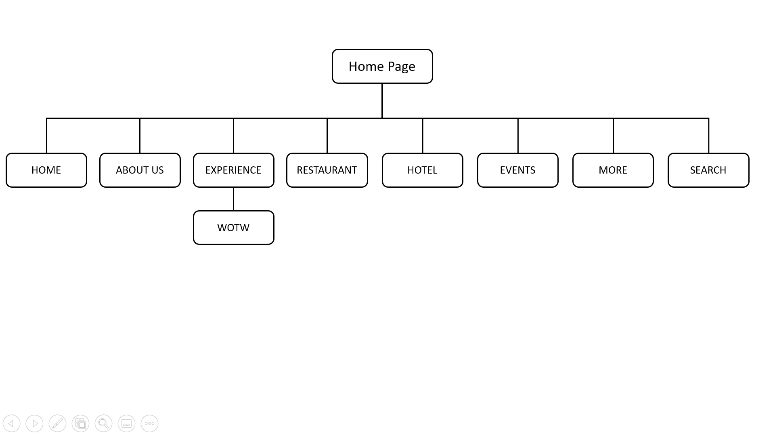

*Sitemap of Client*

- Admin:

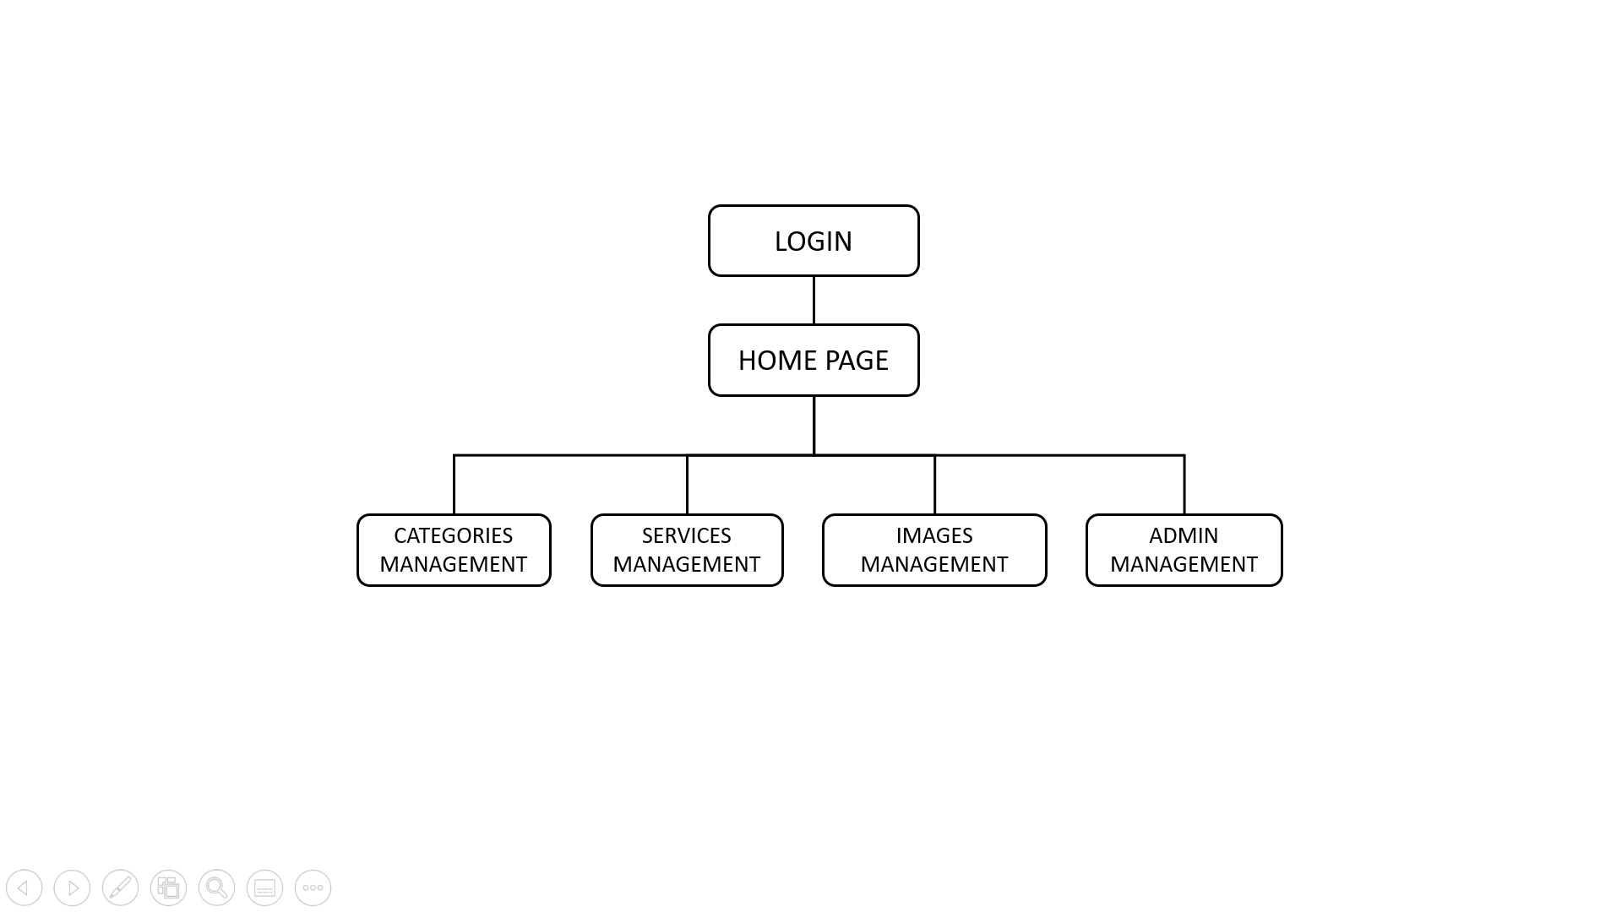

*Sitemap of admin*

# 4. Website Display

## 4.1. User Interface

- Homepage:

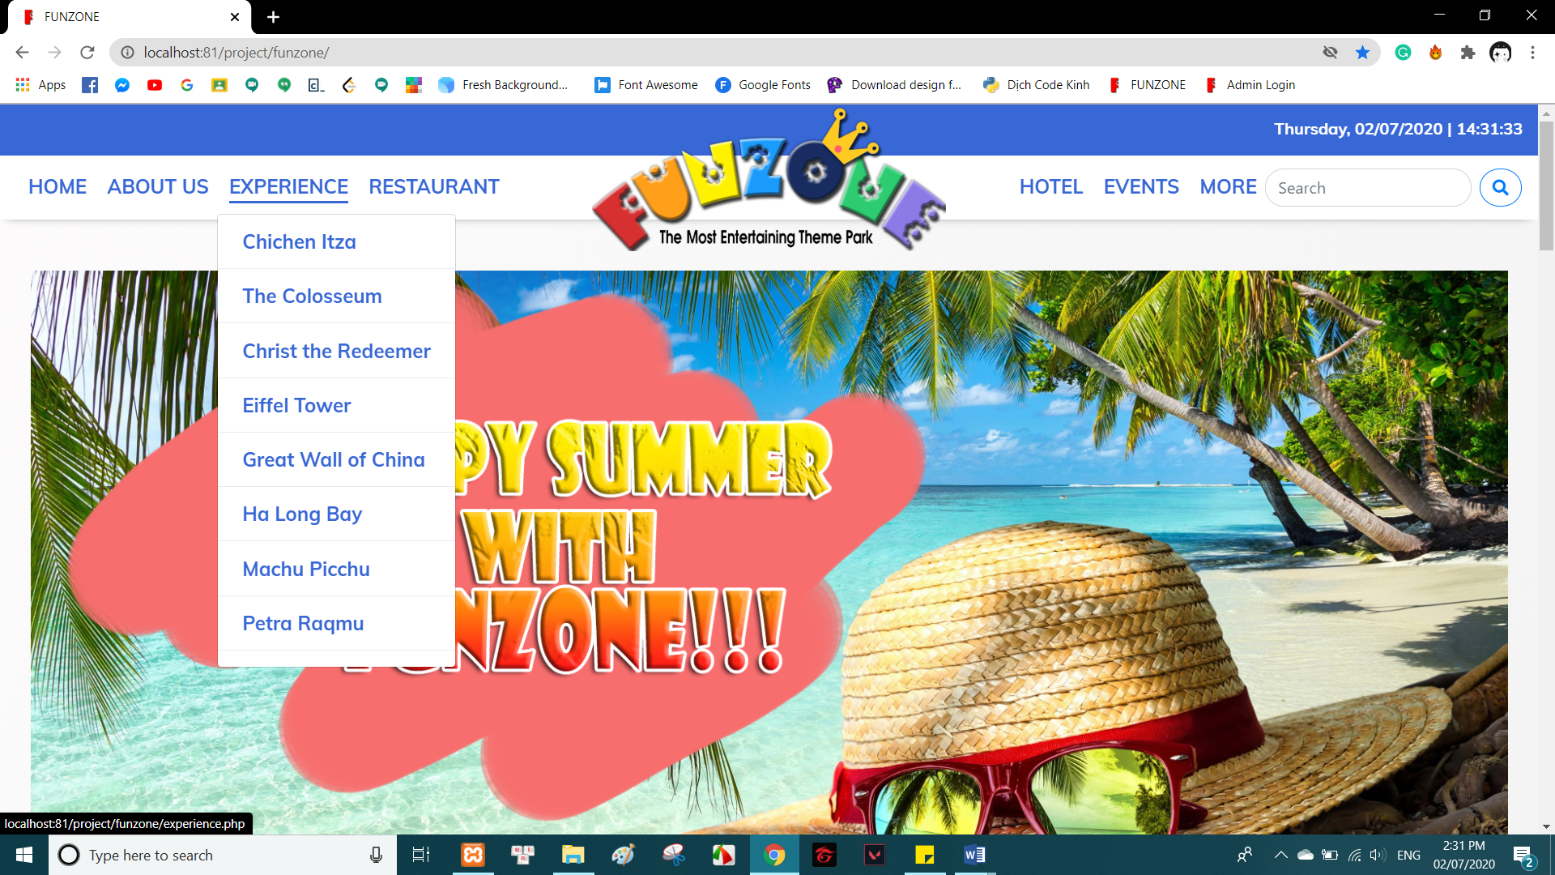

*Navbar*

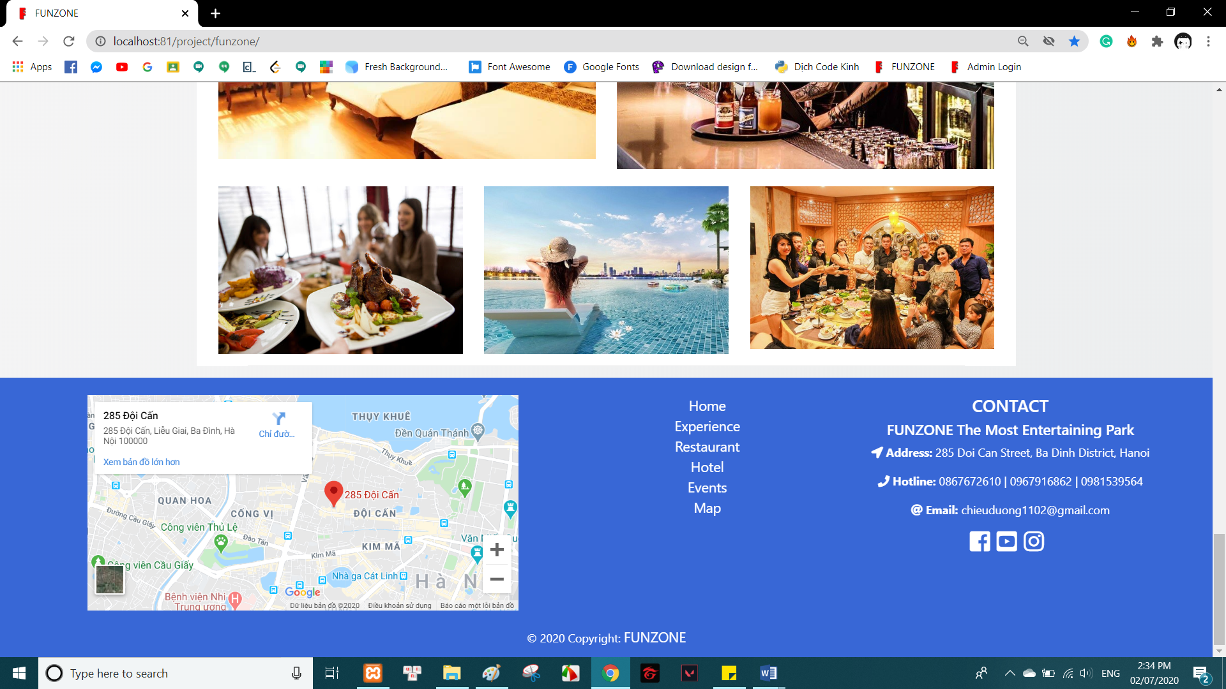

*Footer*

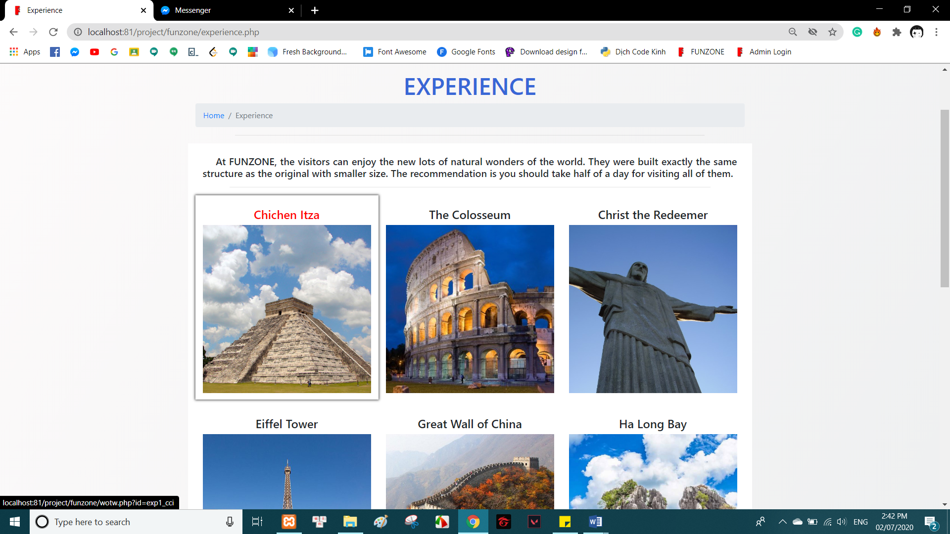

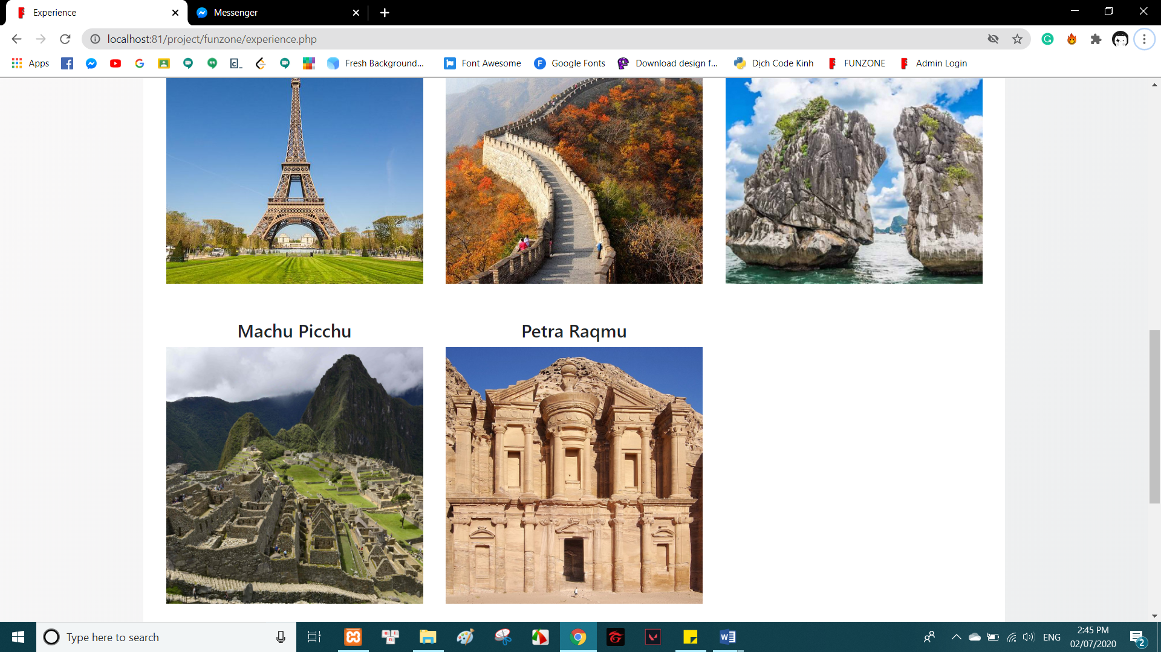

*Experience’s page*

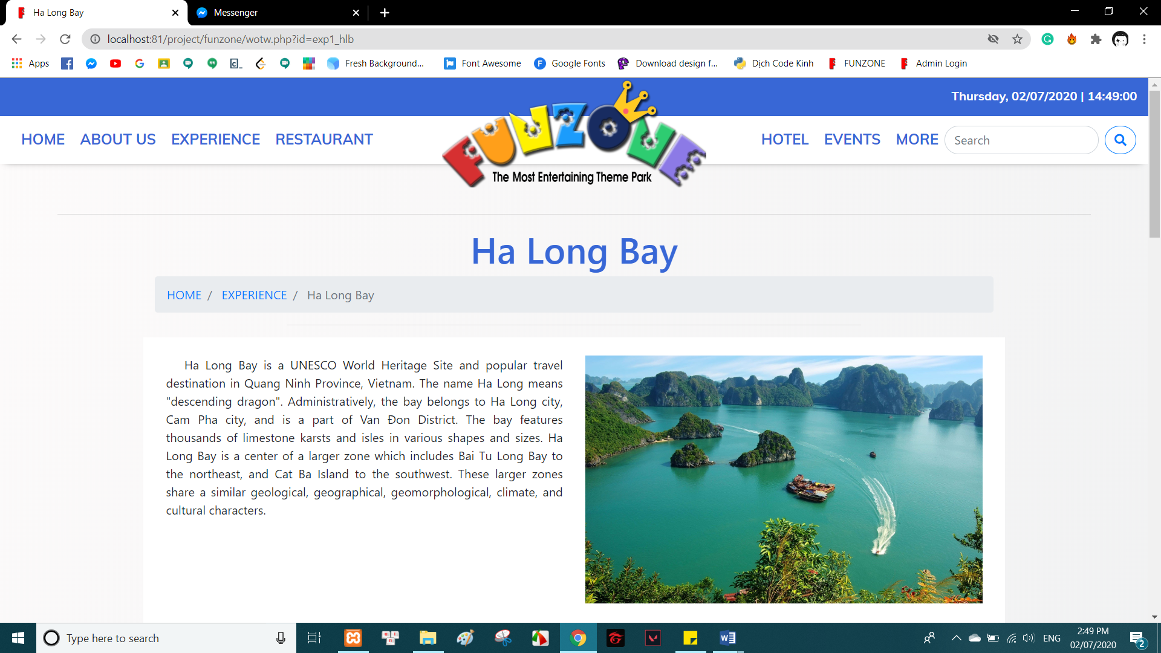

*Ha Long Bay*

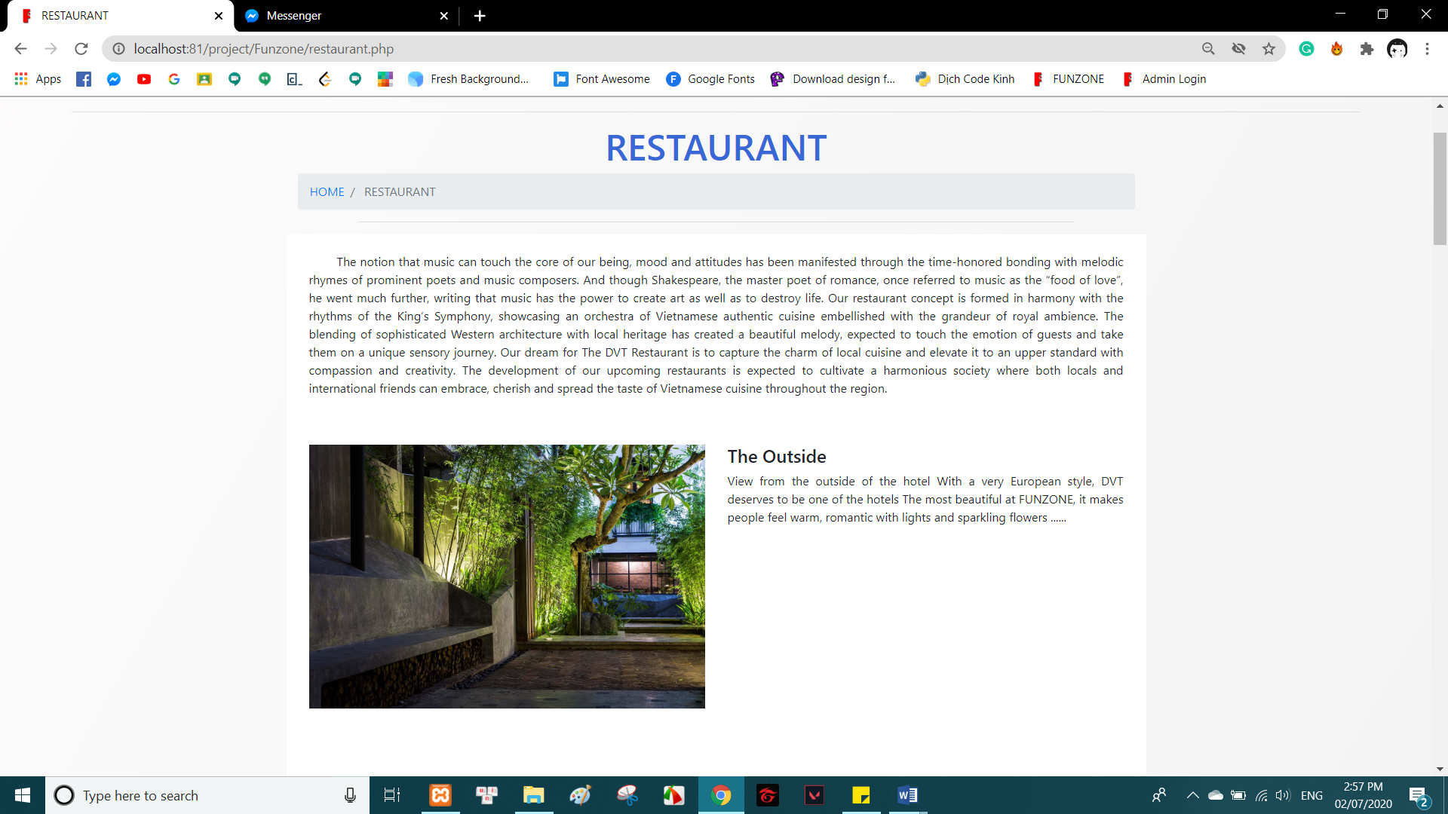

*Restaurant*

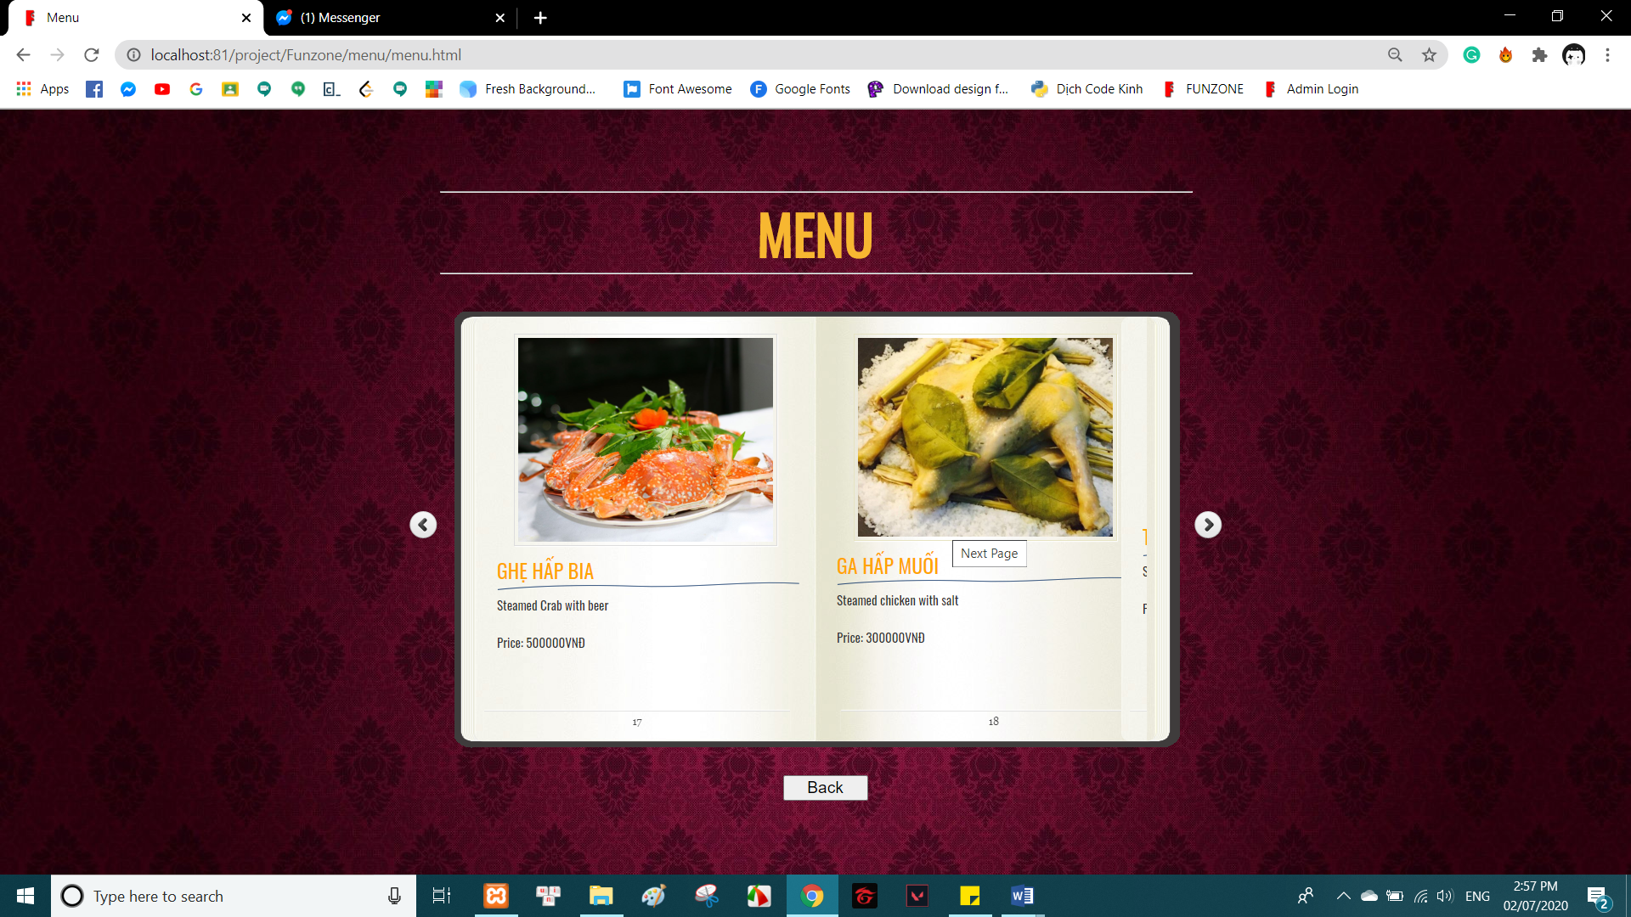

*Menu*

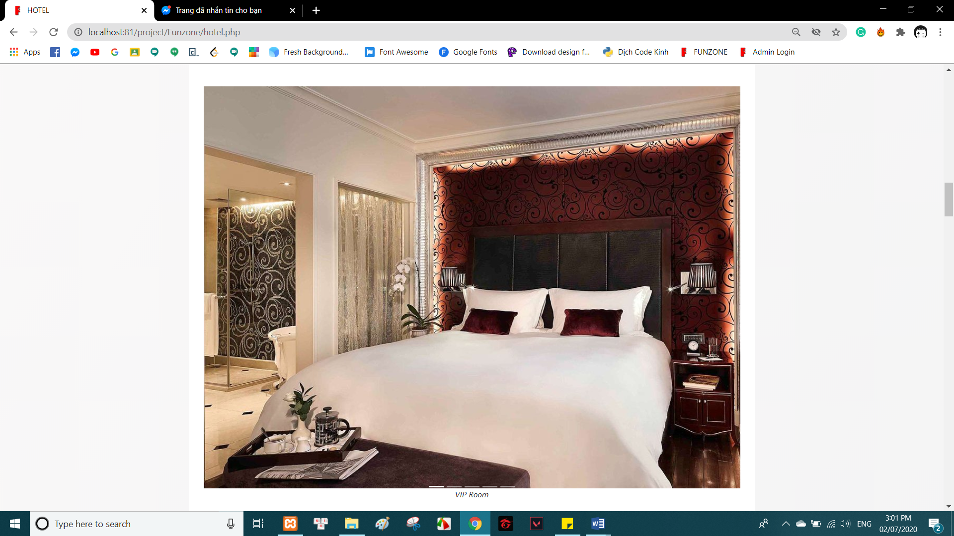

*Slidesshow VIP room*

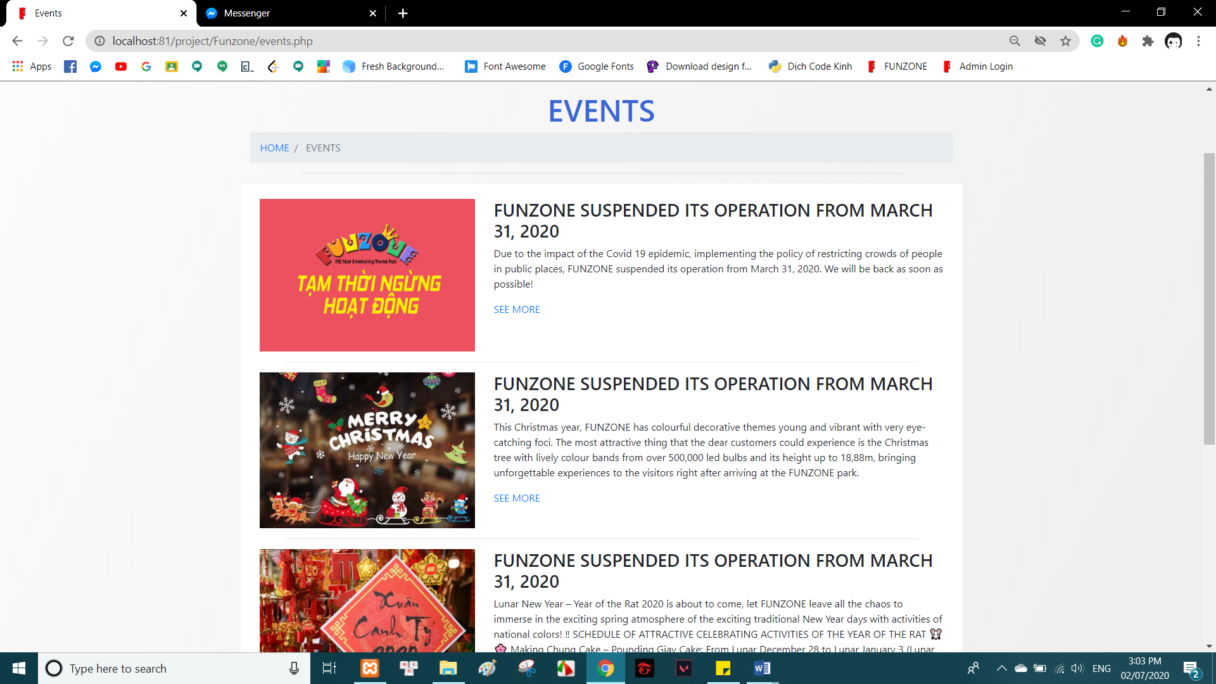

*Event’s page*

## 4.2 Admin Interface

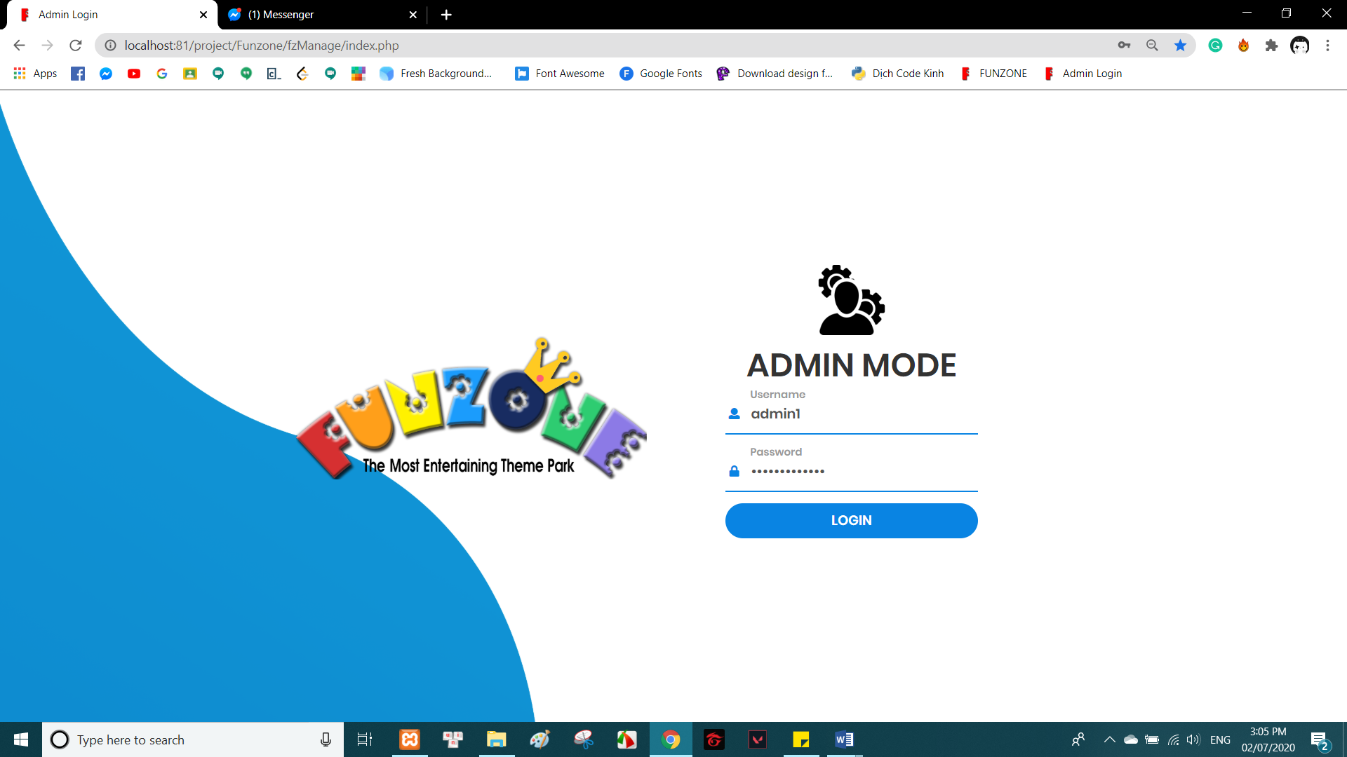

*Login page*

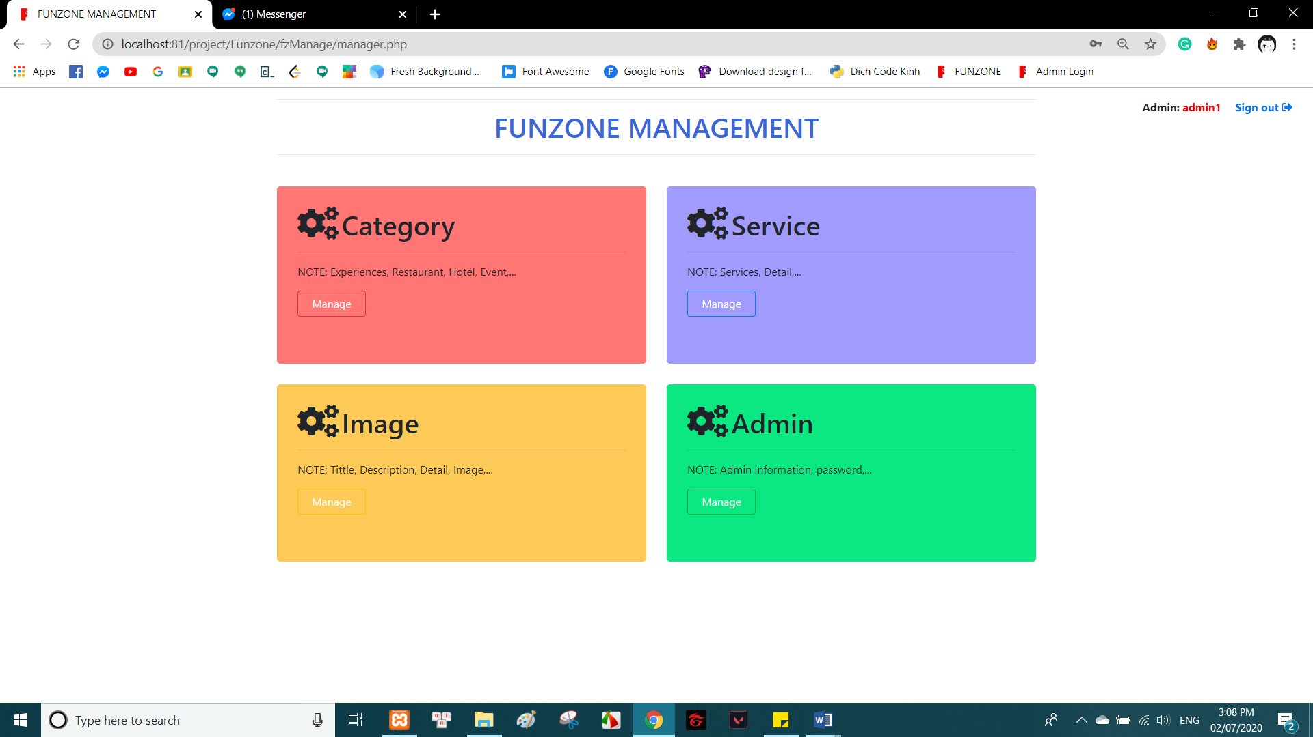

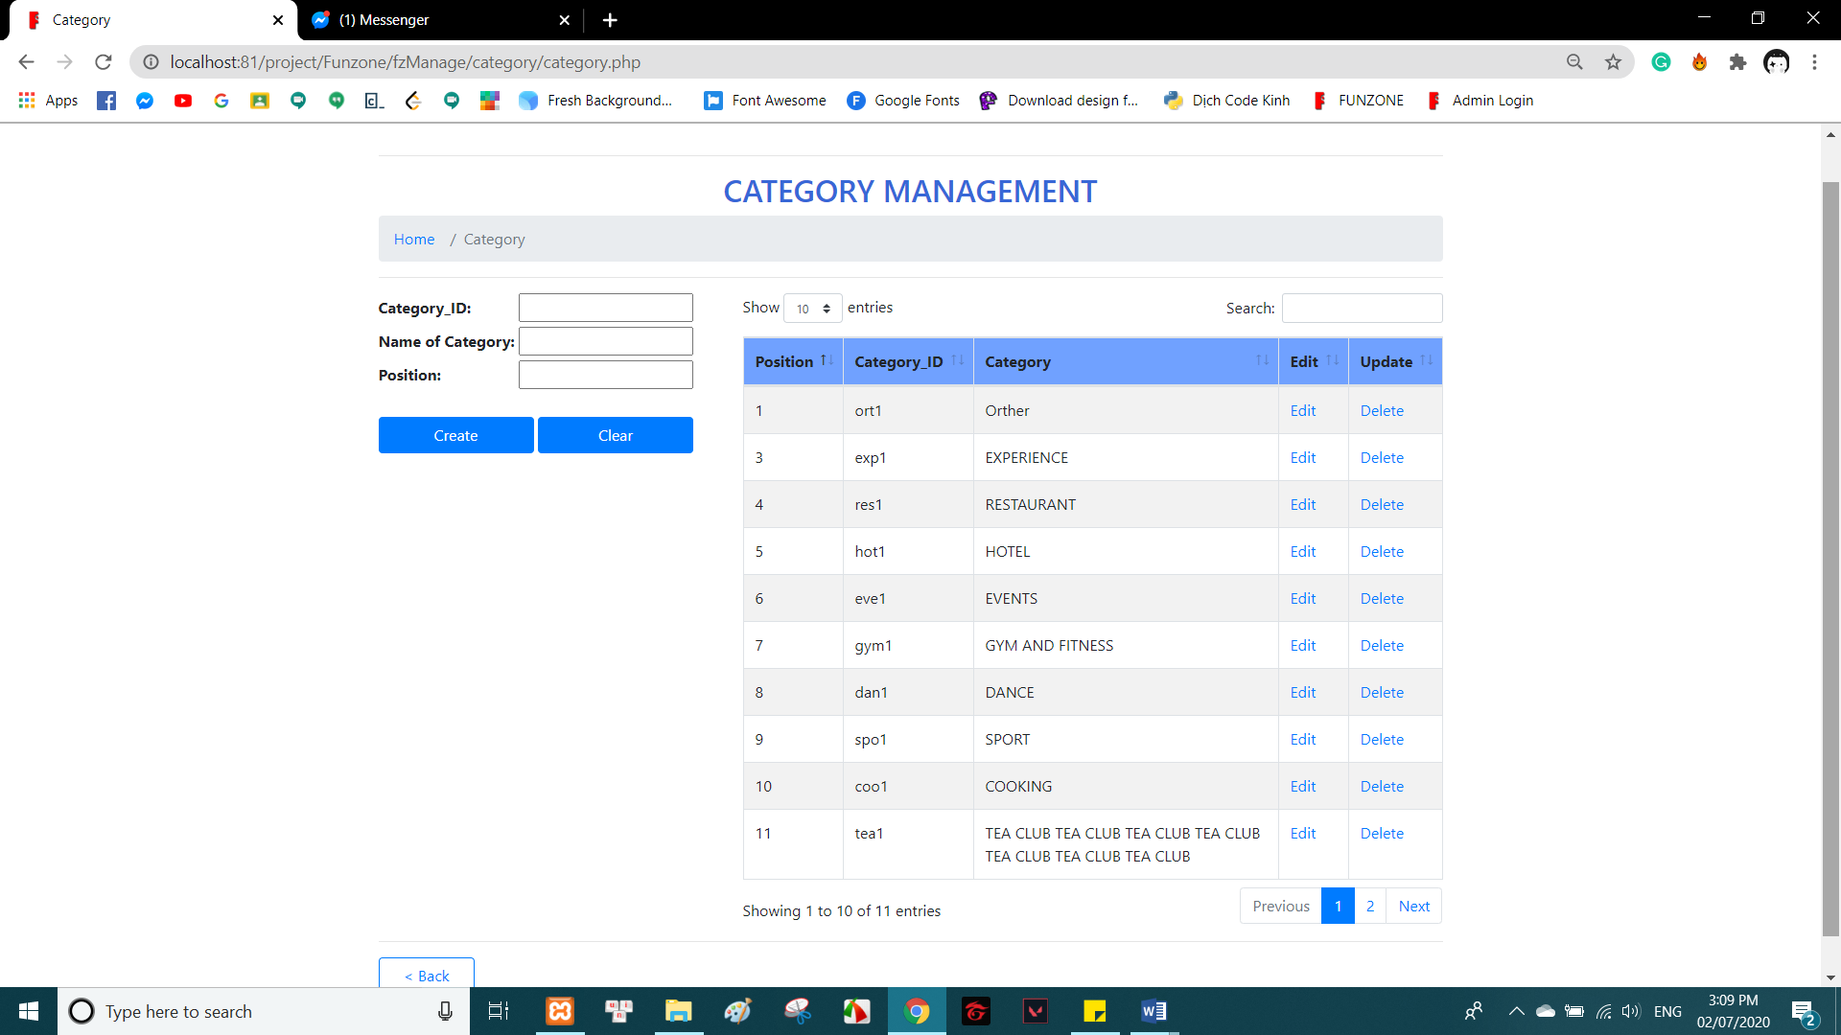

*Category Management*

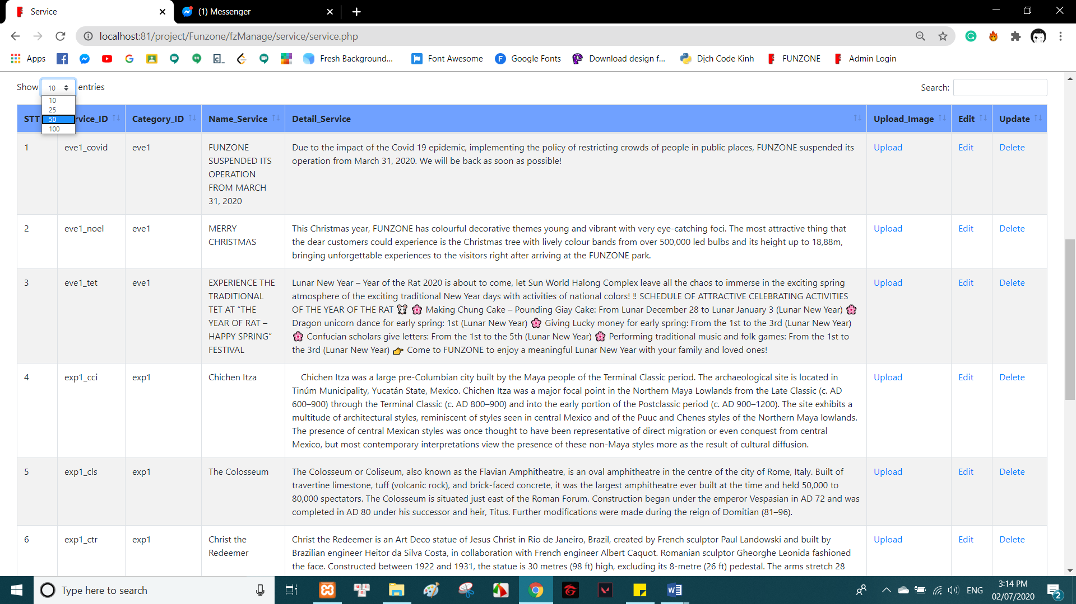

*Content in service’s table*

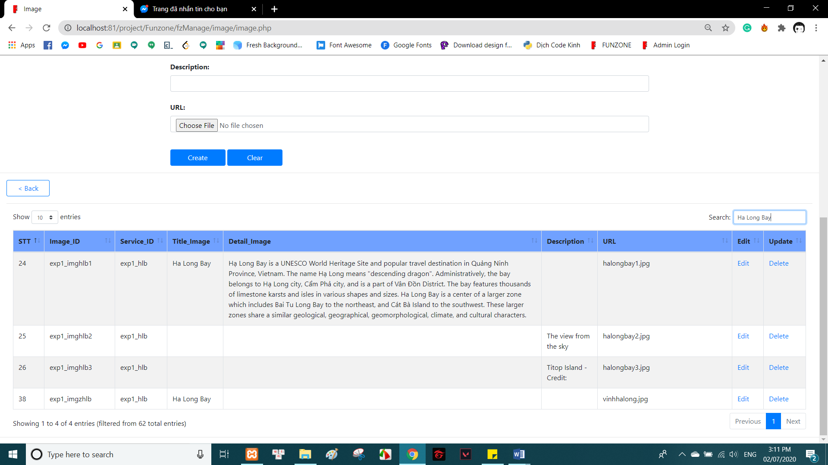

*Data table*

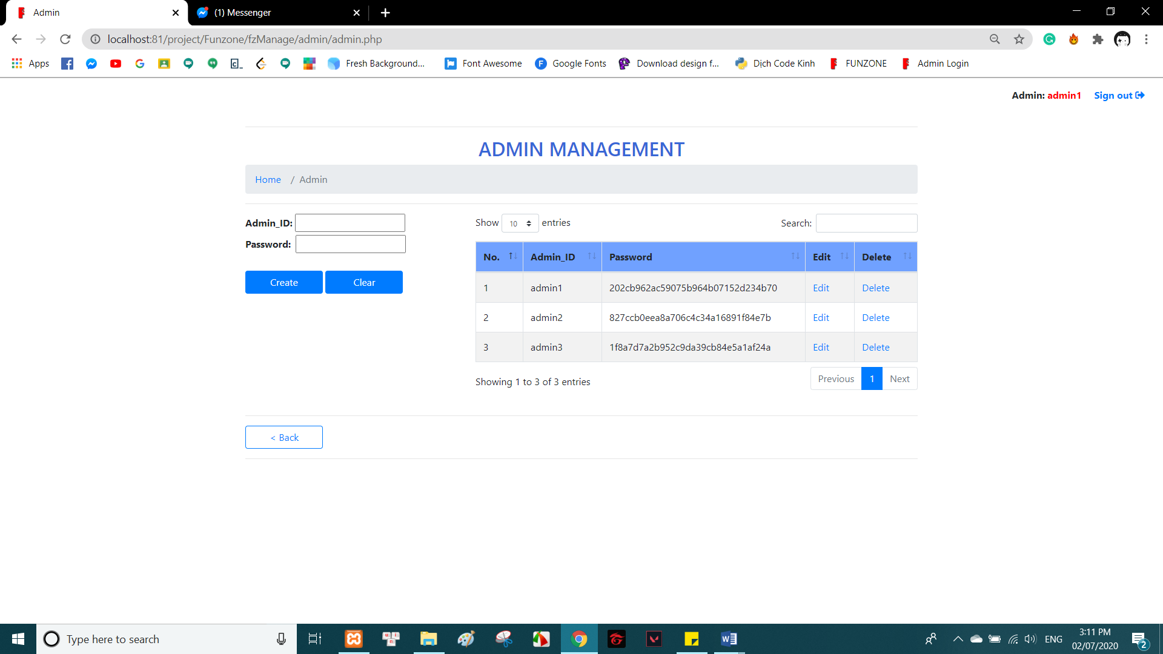

*Md5 password*

# 5. Algorithm

**-** Search:

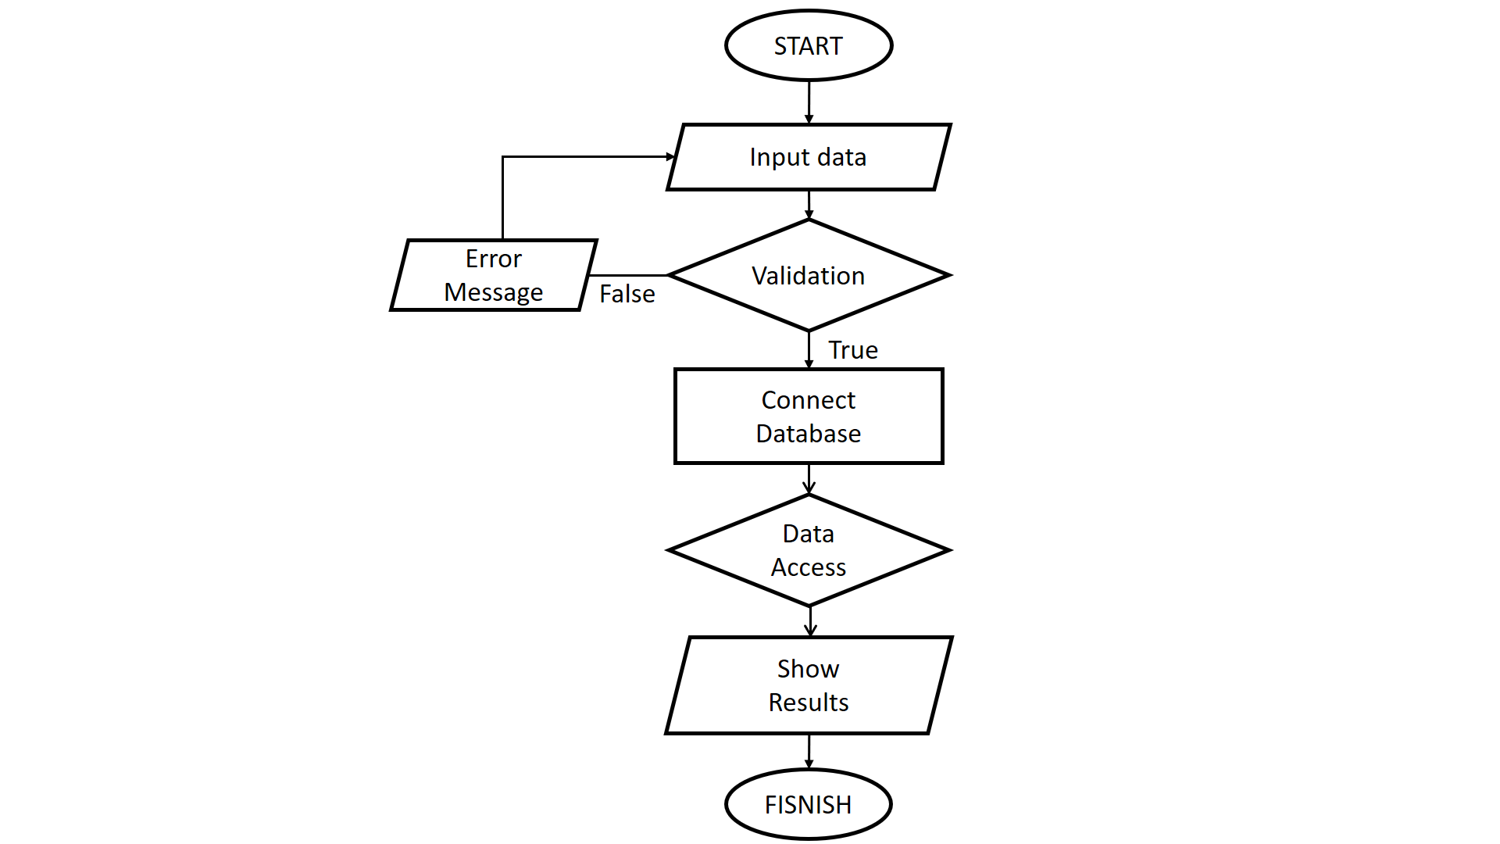

- Login:

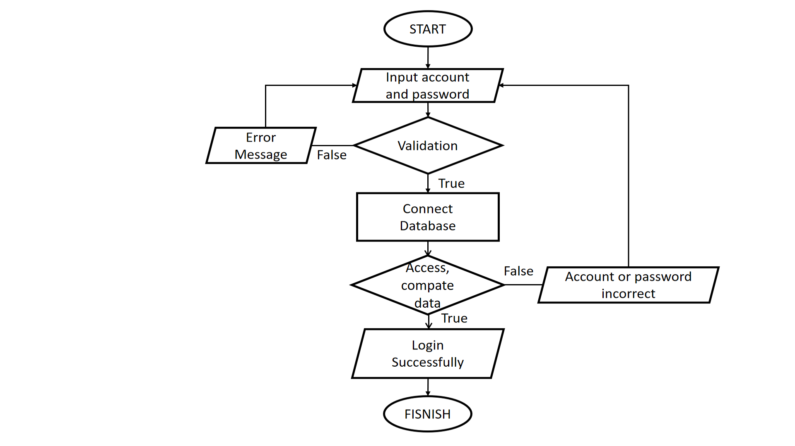

# 6. Conclude and Oriented development

## 6.1 Conclude

- **Advantages: +** Have more experience in job management.

+ Improve teamwork skills, analysis skill.

+ Upgrade code skills, PHP, HTML, CSS, Javascript,…

+ …

- **Defect: +** The system still has many vulnerabilities, imcomplete.

+ UI still has many shortcomings.

+ …

## 6.2 Oriented development

- Develop multi language.

- Develop Reservation function

▪  Description: Applicable to all customers wishing to book services such as tickets, hotel rooms, homestay rooms, and restaurant table reservations.

▪  Input: Customers are required to provide accurate personal information such as full name, phone number, time to book, service name, quantity. Customers click confirm to submit the form. Customers cannot change the information on the form once submitted. If you want to change, contact the Customer Care Center hotline.

▪  Mechanism of action: Sever will receive and records the form of information that the the client has requested. Also, access Database information necessary for payment such as Customer request name, phone number, service name, number, and amount to be paid to prepare for payment steps.

▪  Output: Display form information: Customer request name, phone number, service name, quantity, and amount to be paid. There are buttons: Cancel, Select form of payment, Confirm payment.

o   If the customers select button Cancel then the entire reservation process will be canceled.

o   If customers select button Select a form of payment to choose the form of payment by cash, ATM iBanking,…

o   After choosing the form of payment, customers are allowed to press the button Confirm payment to pay and complete the reservation procedure.

o   Customers are required to complete the steps above to be allowed to Confirm payment.

- Develop more Payment function

▪  Description: There are other forms of payment such as:

o   Direct payment by cash.

o   Make a reservation and pay at the cashier.

o   Pay online with AirPay, ATM-iBanking, Visa, Paypal,…

▪  Input:

o   For direct payment: input not required.

o   For online payment by AirPay: Customers scan QR code to pay.

o    For online payment by ATM-iBanking, Visa: Customers select a bank, login, and complete the required procedures of that bank to make payment...

o  Click the button Confirm payment to complete the payment

▪  Mechanism of action: After customers complete the reservation and pay online successfully, all form information is saved to the Database.

▪  Output: Display notification bar client results. And remind customers to be on schedule to ensure customer benefits. If not, the ticket will be canceled and no refund. Any questions and suggestions, please contact the hotline or send mail to the FUN ZONE.

- Combining new technology to improve and speed up the website.

- Practice and upgrade personal skills